- Tuesday 18th December- Christmas Party – AM Group- 10:30 PM group 2:30
- Wenesday 19th December- visit to HighBank care home (am)/ Archeview care Home (pm)- see below for details.
- Thursday 20th December- last day for afternoon children
- Friday 21st December – last day for morning children
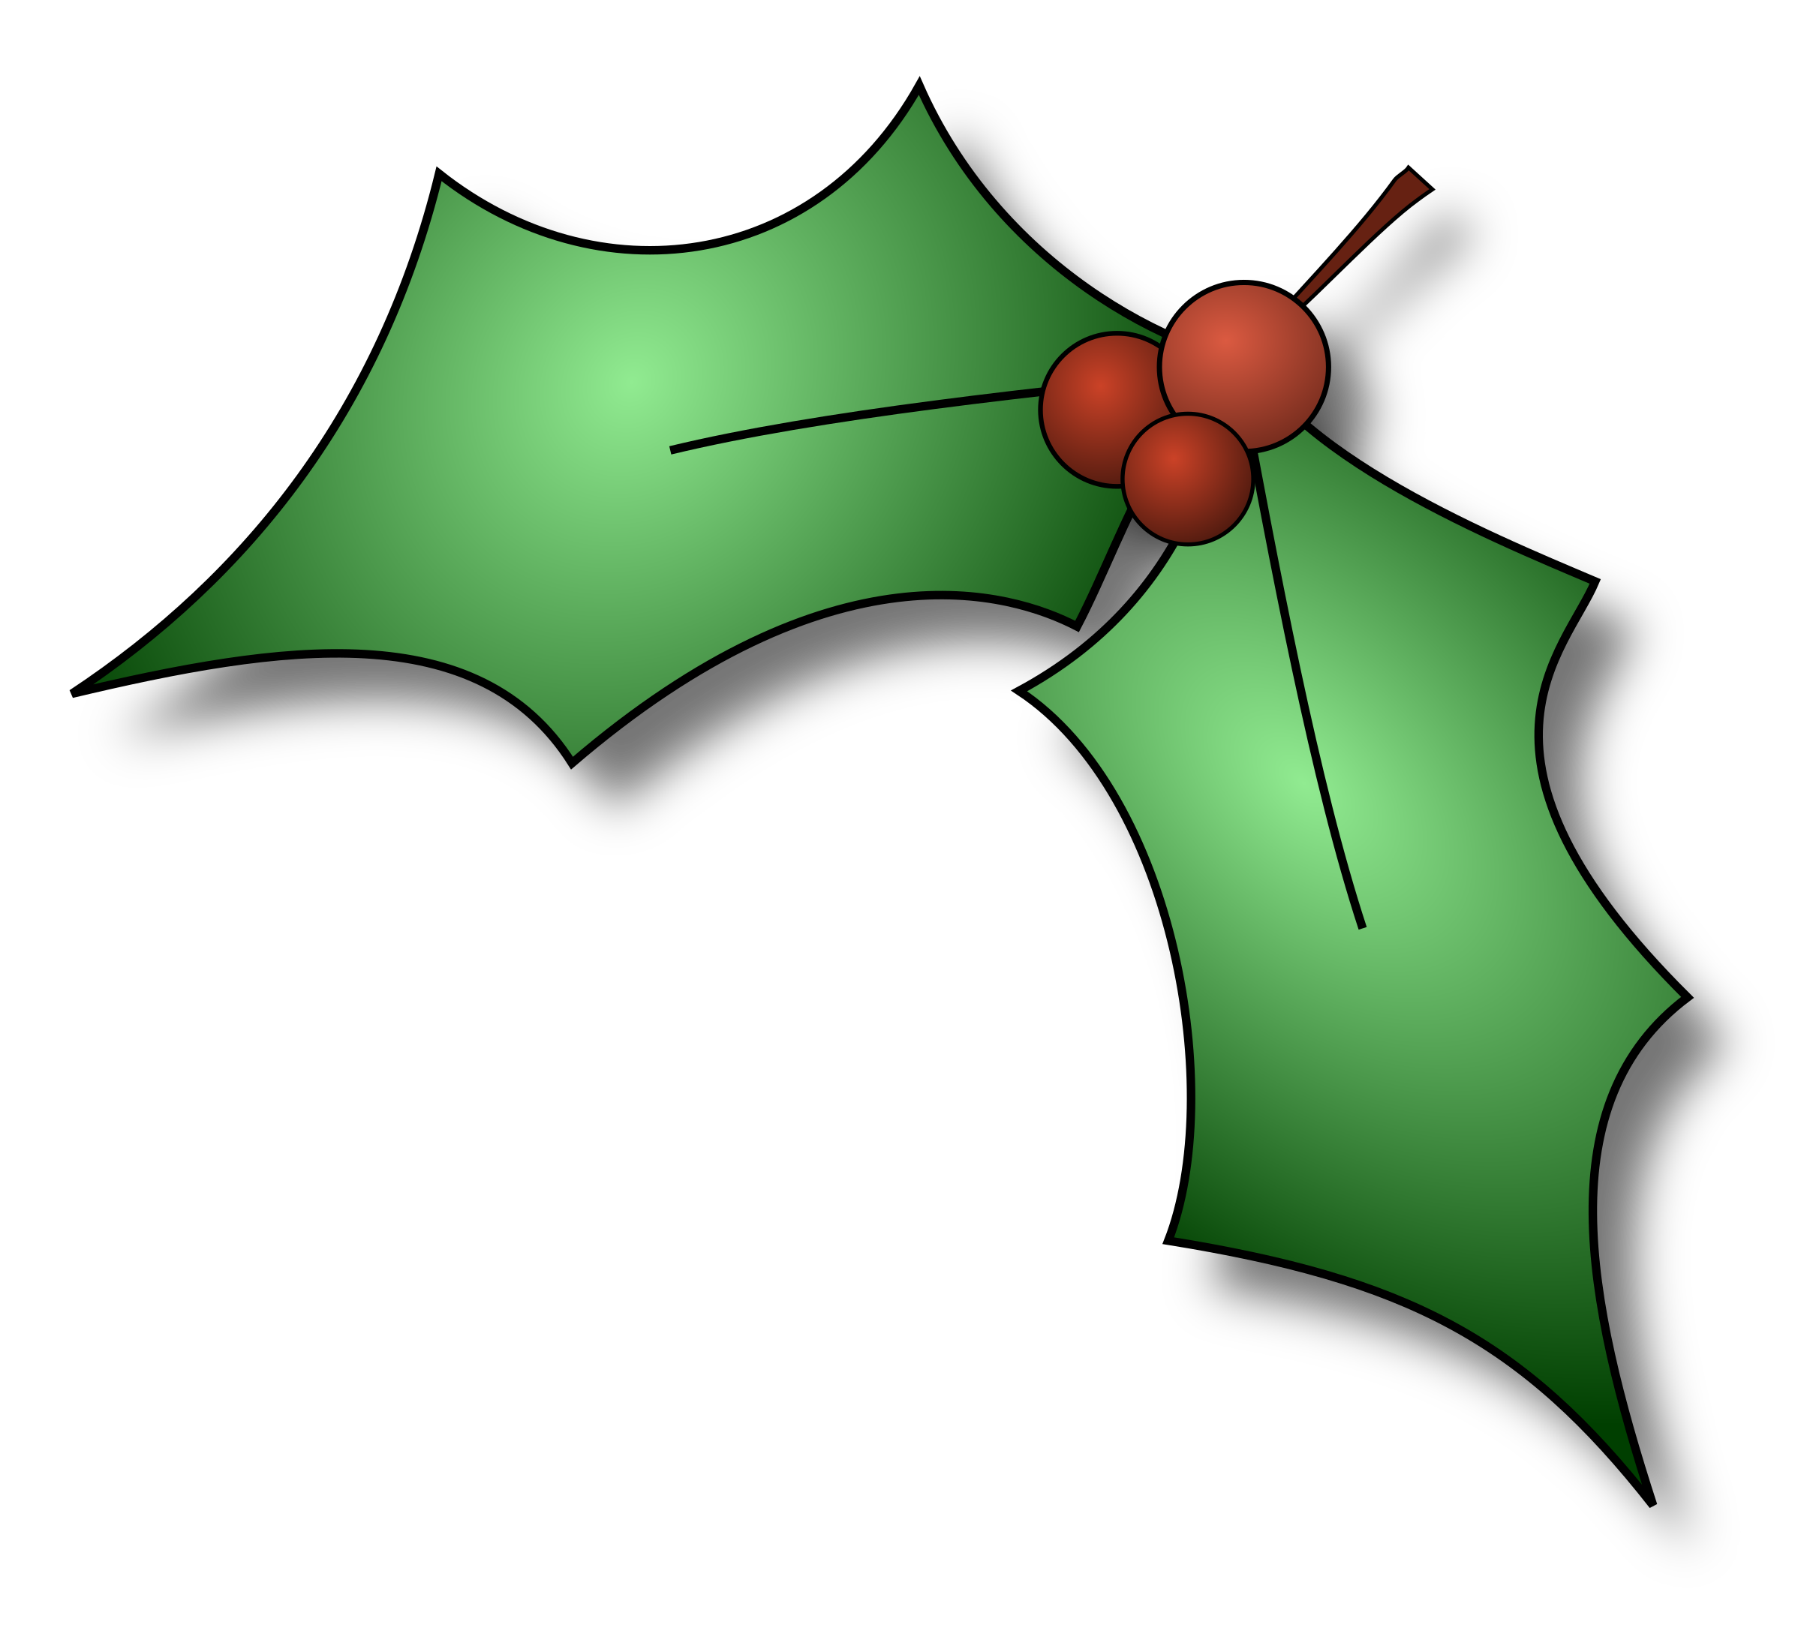
Forest School session
This week is the morning group going to forest schools. Please note there will be no forest schools on Tuesday as it is the nursery Christmas party.

Nursery home Visits- Please see date above
High Bank Care Home- 9:30-11am
Archveiw care Home 1:30-3pm
The children will have the choice to come to the care home to sing their Christmas song to the residents. We hope it will get them in the Christmas spirit. Please let a member of staff know if you would prefer for your children not to go. Also please let a member of staff know if are able to help on this outing. The More the Merrier.

Dobbies garden center
There are a few more visits planned for next week but unfortunately not all the children will get the opportunity to go. If you would prefer you child not to go please let a member of staff know.

Nursery Sing-along
A big thanks to everyone who joined us on Thursday, your children certainly did you proud. The children did a wonderful job and thank you for taking the time to help your child practice the songs at home.


Christmas fair
The Christmas fair made a great amount of £2000. A big thanks you to everyone.

We would like to say a big thanks you to everyone for the continued support in the Nursery.

We hope you have a lovely Christmas and see you all in 2019.


